E.S.V.V. Pusphaira

Corona Protocol
May 2020

Dear members,

We are very happy that we are allowed to train, even if it is under certain conditions. To make sure we are able to successfully resume training we ask you to read this protocol carefully. Everyone will have to follow the guidelines, as the SSC will check whether we keep to the agreements made. If that is not the case, we may have to temporally cancel the trainings once again.
If you have questions after reading this document, email your question to bestuur@pusphaira.nl . We will collect the questions and put the answers in a newsitem on our website.

Training schedule
The trainings will be shortened by half an hour. This means that there will be a new training schedule.
- Monday’s lower teams training shall take place from 19:00 till 20:00
- Tuesday’s and Thursday’s ladies’ trainings shall take place from 19:00 till 20:00
- Tuesday’s and Thursday’s men's selection training shall take place from 20:30 till 21:30
- Wednesday’s training for trainings members and P3 shall take place from 19:00 till 20:00
- Wednesday’s training for P4, P5 and P6 shall take place from 20:30 till 21:30

Registering for trainings
A maximum of 30 members can be present during a training. To check this and avoid problems you will have to register for every training you want to visit. This will be done via google drive. If you are not one of the first 30 on the list for a training, put your name beneath the list so that we can give you priority in the next training and therefore have a fair system.

Temporary new entrance and exit
To avoid crowds at the entrance and exit, there is an arrival and departure protocol.

Arrival
You arrive at the training grounds via the parking lot at Woenselse Boys. So not via the sports centre side (Ventweg). The parking lot is the only access to the training grounds. There the rad is split in two. Take the left lane when you arrive. Now cycle straight until you can go right between the bushes. This is indicated with ribbon and signs. After the changing rooms, immediately turn right towards the bicycle shed. Put your bike here. Keep away from other people arriving and any departing members. Now walk along the path towards the large gate near the lawn (between our lawn and the main field). At the rear of the artificial grass field, pieces of ribbon have been placed on the fence. Choose a spot between the restricted sections. Here you can put your belongings.

Departure
You leave the field through the small gate to the left of the dug-outs. Walk straight ahead and turn right and walk past the dressing rooms. So, you walk around the entire dressing room building block back to your bike. Cycle back on the far side so that you do not encounter oncoming traffic. Make sure you choose the left lane where the road is split in two again. See the figure below for clarification.
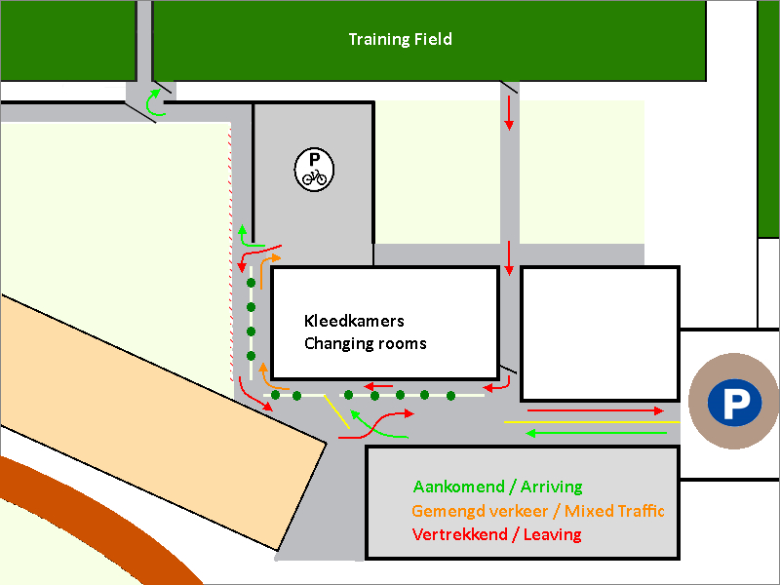

Dressing rooms are closed
Please note that the dressing rooms will remain closed for now, so you will not be able to use the toilet. Everyone is expected to arrive dressed to the trainings.

Corona measure for trainings
Before the training (AT HOME)
- Read all the rules in this document carefully.
- Take a good look at your new training time(s).
- Think if you feel healthy: stay home if you have a cold or are feeling unwell.
- Change clothes at home, fill your own drinking bottle and go to the toilet again, the dressing rooms are closed.
- Bring two shirts as an alternative to using vests (preferably in the color blue or green).
- Wash your hands just before you leave for training.
- Leave on time, but do not arrive too early, due to spreading the crowds at the gate and bicycle stands.

Arrival at the training
- Do not cycle to the trainings together.
- If your training starts at 19:00, you will arrive between 18:50 and 19:00.
- If your training starts at 20:30, you will arrive between 20:20 and 20:30.
- Check the arrival section for a detailed explanation of the measures regarding your arrival
- You enter the field through the large gate and walk directly to the other side, put your bag with your own bottle of water in a compartment and go directly to a rondo where there is space.
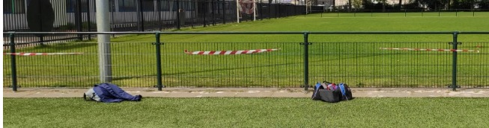
- Touch as little as possible.
- Do not walk through the rondos on the way to the bag compartments.

During the training
- Always keep a distance of 1.5 meters from each and from the trainers.
- This also applies if you are family or in the same household (an outsider does not know this).
- Don’t empty your nose.
- Do not spit on the ground.
- Sneeze and cough in your elbow.
- Only tough the materials if the trainer asks you to. As soon as you are done, immediately use the disinfectant on the field.
- Do not touch the ball with your hands.
- You are not allowed to head the ball.
- Follow the instructions of the trainers.

After the training
- Check the departure section for a detailed explanation of the measure regarding your departure.
- Give each other space when leaving: also then keep a distance of 1.5 meters.
- Do not linger but leave towards your home immediately after training.
- Cycle home alone.
- Wash your hands again when you return home.

Failure to follow any of these rules will result in trainers or board members requesting you to leave the training.

Resuming the trainings carries a risk of spreading the corona virus to yourself, other athletes and the trainers. We count on your best effort and discipline to comply with the rules as aforementioned. Stay at home if you are ill yourself or if one of your roommates has a fever or complaints.

We look forward to receiving you all back on the football field in good health and with active attitude!

55th board of E.S.V.V. Pusphaira

If there are any inconsistencies between the Dutch version of this document, then the Dutch version will prevail.

